Quiz_Lecture22

Name：刘承奇 Student ID：2018533249

1. Please indicate which components are eigenvectors? How many eigenvectors?

There are 15 eigenvectors. Except the image in the top left corner, each image can be regarded as an eigenvector. (We can connect its pixels along the length or width to form a vector.)

These eigenvectors are (from big to small): 

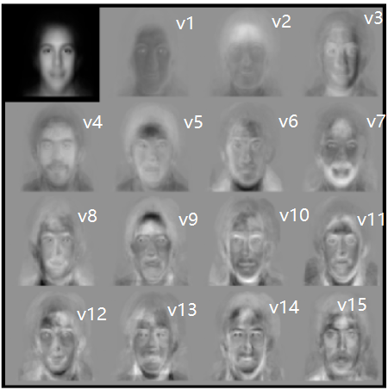

1. How can you reconstruct the face image x based on the eigenvectors you found in (1)? Please show your formula.

We can select these 15 eigenvectors to form a set of orthogonal bases. Let  be the average face vector.



 is a scalar, denoting the weight of the kth eigenvector (eigenface). By the properties of projection we have that



These form a weight vector . It can be used as a comparison in face recognition.